DBMS Concurrency Control
Concurrency Control is the management procedure that is required for controlling concurrent execution of the operations that take place on a database.
But before knowing about concurrency control, we should know about concurrent execution.

Concurrent Execution in DBMS
- In a multi-user system, multiple users can access and use the same database at one time, which is known as the concurrent execution of the database. It means that the same database is executed simultaneously on a multi-user system by different users.
- While working on the database transactions, there occurs the requirement of using the database by multiple users for performing different operations, and in that case, concurrent execution of the database is performed.
- The thing is that the simultaneous execution that is performed should be done in an interleaved manner, and no operation should affect the other executing operations, thus maintaining the consistency of the database. Thus, on making the concurrent execution of the transaction operations, there occur several challenging problems that need to be solved.

Problems with Concurrent Execution
In a database transaction, the two main operations are READ and WRITE operations. So, there is a need to manage these two operations in the concurrent execution of the transactions as if these operations are not performed in an interleaved manner, and the data may become inconsistent. So, the following problems occur with the Concurrent Execution of the operations:

Problem 1: Lost Update Problems (W - W Conflict)
The problem occurs when two different database transactions perform the read/write operations on the same database items in an interleaved manner (i.e., concurrent execution) that makes the values of the items incorrect hence making the database inconsistent.
For example:
Consider the below diagram where two transactions T_{X} and T_{Y}, are performed on the same account A where the balance of account A is $300.
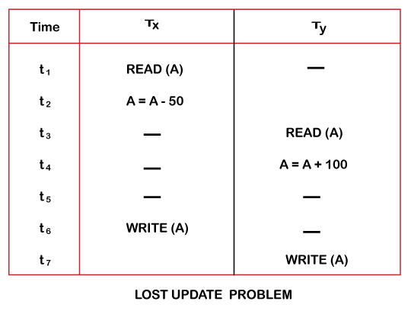
- At time t1, transaction T_{X} reads the value of account A, i.e., $300 (only read).
- At time t2, transaction T_{X} deducts $50 from account A that becomes $250 (only deducted and not updated/write).
- Alternately, at time t3, transaction T_{Y} reads the value of account A that will be $300 only because T_{X} didn't update the value yet.
- At time t4, transaction T_{Y} adds $100 to account A that becomes $400 (only added but not updated/write).
- At time t6, transaction T_{X} writes the value of account A that will be updated as $250 only, as T_{Y} didn't update the value yet.
- Similarly, at time t7, transaction T_{Y} writes the values of account A, so it will write as done at time t4 that will be $400. It means the value written by T_{X} is lost, i.e., $250 is lost.
Hence data becomes incorrect, and database sets to inconsistent.

Dirty Read Problems (W-R Conflict)
The dirty read problem occurs when one transaction updates an item of the database, and somehow the transaction fails, and before the data gets rollback, the updated database item is accessed by another transaction. There comes the Read-Write Conflict between both transactions.
For example:
Consider two transactions T_{X} and T_{Y} in the below diagram performing read/write operations on account A where the available balance in account A is $300:
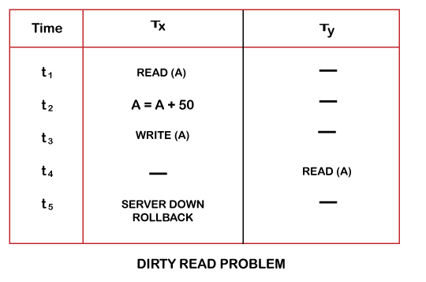
- At time t1, transaction T_{X} reads the value of account A, i.e., $300.
- At time t2, transaction T_{X} adds $50 to account A that becomes $350.
- At time t3, transaction T_{X} writes the updated value in account A, i.e., $350.
- Then at time t4, transaction T_{Y} reads account A that will be read as $350.
- Then at time t5, transaction T_{X} rollbacks due to server problem, and the value changes back to $300 (as initially).
- But the value for account A remains $350 for transaction T_{Y} as committed, which is the dirty read and therefore known as the Dirty Read Problem.

Unrepeatable Read Problem (W-R Conflict)
Also known as Inconsistent Retrievals Problem that occurs when in a transaction, two different values are read for the same database item.
For example:
Consider two transactions, T_{X} and T_{Y}, performing the read/write operations on account A, having an available balance = $300. The diagram is shown below:
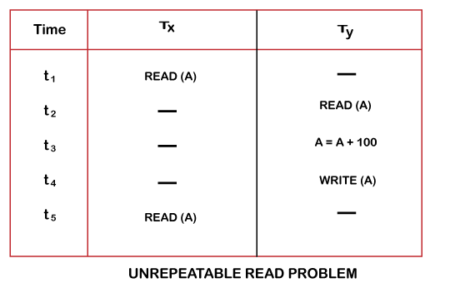
- At time t1, transaction T_{X} reads the value from account A, i.e., $300.
- At time t2, transaction T_{Y} reads the value from account A, i.e., $300.
- At time t3, transaction T_{Y} updates the value of account A by adding $100 to the available balance, and then it becomes $400.
- At time t4, transaction T_{Y} writes the updated value, i.e., $400.
- After that, at time t5, transaction T_{X} reads the available value of account A, and that will be read as $400.
- It means that within the same transaction T_{X}, it reads two different values of account A, i.e., $ 300 initially, and after updation made by transaction T_{Y}, it reads $400. It is an unrepeatable read and is therefore known as the Unrepeatable read problem.
Thus, in order to maintain consistency in the database and avoid such problems that take place in concurrent execution, management is needed, and that is where the concept of Concurrency Control comes into role.

Concurrency Control
Concurrency Control is the working concept that is required for controlling and managing the concurrent execution of database operations and thus avoiding the inconsistencies in the database. Thus, for maintaining the concurrency of the database, we have the concurrency control protocols.

Concurrency Control Protocols
The concurrency control protocols ensure the atomicity, consistency, isolation, durability and serializability of the concurrent execution of the database transactions. Therefore, these protocols are categorized as:
- Lock Based Concurrency Control Protocol
- Time Stamp Concurrency Control Protocol
- Validation Based Concurrency Control Protocol

Lock-Based Protocol
In this type of protocol, any transaction cannot read or write data until it acquires an appropriate lock on it. There are two types of lock:
1. Shared lock:
- It is also known as a Read-only lock. In a shared lock, the data item can only read by the transaction.
- It can be shared between the transactions because when the transaction holds a lock, then it can't update the data on the data item.
2. Exclusive lock:
- In the exclusive lock, the data item can be both reads as well as written by the transaction.
- This lock is exclusive, and in this lock, multiple transactions do not modify the same data simultaneously.

There are four types of lock protocols available:

1. Simplistic lock protocol
It is the simplest way of locking the data while transaction. Simplistic lock-based protocols allow all the transactions to get the lock on the data before insert or delete or update on it. It will unlock the data item after completing the transaction.

2. Pre-claiming Lock Protocol
- Pre-claiming Lock Protocols evaluate the transaction to list all the data items on which they need locks.
- Before initiating an execution of the transaction, it requests DBMS for all the lock on all those data items.
- If all the locks are granted then this protocol allows the transaction to begin. When the transaction is completed then it releases all the lock.
- If all the locks are not granted then this protocol allows the transaction to rolls back and waits until all the locks are granted.
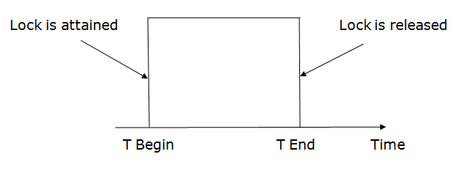

3. Two-phase locking (2PL)
- The two-phase locking protocol divides the execution phase of the transaction into three parts.
- In the first part, when the execution of the transaction starts, it seeks permission for the lock it requires.
- In the second part, the transaction acquires all the locks. The third phase is started as soon as the transaction releases its first lock.
- In the third phase, the transaction cannot demand any new locks. It only releases the acquired locks.
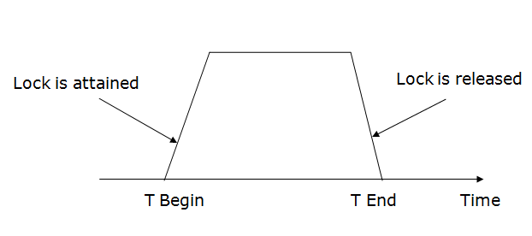
There are two phases of 2PL:
Growing phase: In the growing phase, a new lock on the data item may be acquired by the transaction, but none can be released.
Shrinking phase: In the shrinking phase, existing lock held by the transaction may be released, but no new locks can be acquired.
In the below example, if lock conversion is allowed then the following phase can happen:
- Upgrading of lock (from S(a) to X (a)) is allowed in growing phase.
- Downgrading of lock (from X(a) to S(a)) must be done in shrinking phase.
Example:
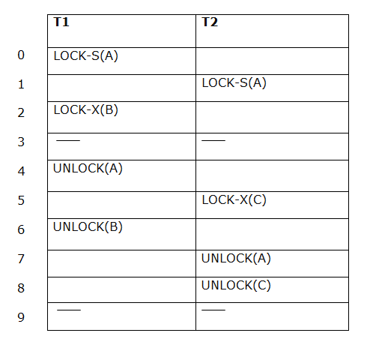
T
he following way shows how unlocking and locking work with 2-PL.
Transaction T1:
- Growing phase: from step 1-3
- Shrinking phase: from step 5-7
- Lock point: at 3
Transaction T2:
- Growing phase: from step 2-6
- Shrinking phase: from step 8-9
- Lock point: at 6

4. Strict Two-phase locking (Strict-2PL)
- The first phase of Strict-2PL is similar to 2PL. In the first phase, after acquiring all the locks, the transaction continues to execute normally.
- The only difference between 2PL and strict 2PL is that Strict-2PL does not release a lock after using it.
- Strict-2PL waits until the whole transaction to commit, and then it releases all the locks at a time.
- Strict-2PL protocol does not have shrinking phase of lock release.
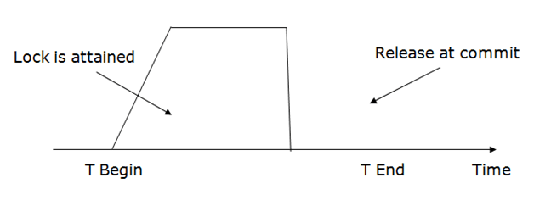
It does not have cascading abort as 2PL does.

Timestamp Ordering Protocol
- The Timestamp Ordering Protocol is used to order the transactions based on their Timestamps. The order of transaction is nothing but the ascending order of the transaction creation.
- The priority of the older transaction is higher that's why it executes first. To determine the timestamp of the transaction, this protocol uses system time or logical counter.
- The lock-based protocol is used to manage the order between conflicting pairs among transactions at the execution time. But Timestamp based protocols start working as soon as a transaction is created.
- Let's assume there are two transactions T1 and T2. Suppose the transaction T1 has entered the system at 007 times and transaction T2 has entered the system at 009 times. T1 has the higher priority, so it executes first as it is entered the system first.
- The timestamp ordering protocol also maintains the timestamp of last 'read' and 'write' operation on a data.
Basic Timestamp ordering protocol works as follows:
1. Check the following condition whenever a transaction Ti issues a Read (X) operation:
- If W_TS(X) >TS(Ti) then the operation is rejected.
- If W_TS(X) <= TS(Ti) then the operation is executed.
- Timestamps of all the data items are updated.
2. Check the following condition whenever a transaction Ti issues a Write(X) operation:
- If TS(Ti) < R_TS(X) then the operation is rejected.
- If TS(Ti) < W_TS(X) then the operation is rejected and Ti is rolled back otherwise the operation is executed.
Where,
TS(TI) denotes the timestamp of the transaction Ti.
R_TS(X) denotes the Read time-stamp of data-item X.
W_TS(X) denotes the Write time-stamp of data-item X.

Advantages and Disadvantages of TO protocol:
- TO protocol ensures serializability since the precedence graph is as follows:
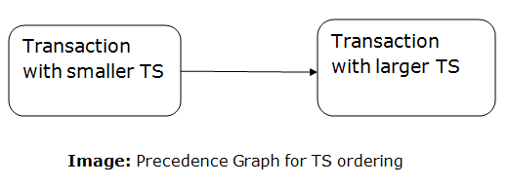
- TS protocol ensures freedom from deadlock that means no transaction ever waits.
- But the schedule may not be recoverable and may not even be cascade- free.

Recoverability of Schedule
Sometimes a transaction may not execute completely due to a software issue, system crash or hardware failure. In that case, the failed transaction has to be rollback. But some other transaction may also have used value produced by the failed transaction. So we also have to rollback those transactions.
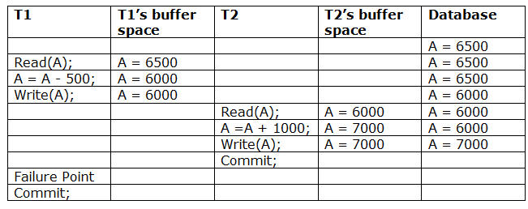
The above table 1 shows a schedule which has two transactions. T1 reads and writes the value of A and that value is read and written by T2. T2 commits but later on, T1 fails. Due to the failure, we have to rollback T1. T2 should also be rollback because it reads the value written by T1, but T2 can't be rollback because it already committed. So this type of schedule is known as irrecoverable schedule.
Irrecoverable schedule: The schedule will be irrecoverable if Tj reads the updated value of Ti and Tj committed before Ti commit.
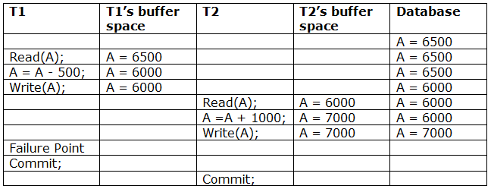
The above table 2 shows a schedule with two transactions. Transaction T1 reads and writes A, and that value is read and written by transaction T2. But later on, T1 fails. Due to this, we have to rollback T1. T2 should be rollback because T2 has read the value written by T1. As it has not committed before T1 commits so we can rollback transaction T2 as well. So it is recoverable with cascade rollback.
Recoverable with cascading rollback: The schedule will be recoverable with cascading rollback if Tj reads the updated value of Ti. Commit of Tj is delayed till commit of Ti.
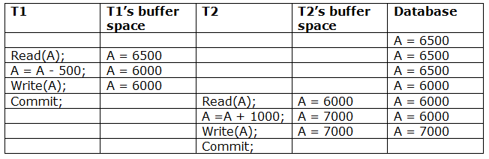
The above Table 3 shows a schedule with two transactions. Transaction T1 reads and write A and commits, and that value is read and written by T2. So this is a cascade less recoverable schedule.

Failure Classification
To find that where the problem has occurred, we generalize a failure into the following categories:
- Transaction failure
- System crash
- Disk failure

1. Transaction failure
The transaction failure occurs when it fails to execute or when it reaches a point from where it can't go any further. If a few transaction or process is hurt, then this is called as transaction failure.
Reasons for a transaction failure could be -
  - Logical errors: If a transaction cannot complete due to some code error or an internal error condition, then the logical error occurs.
  - Syntax error: It occurs where the DBMS itself terminates an active transaction because the database system is not able to execute it. For example, The system aborts an active transaction, in case of deadlock or resource unavailability.

2. System Crash
  - System failure can occur due to power failure or other hardware or software failure. Example: Operating system error.
Fail-stop assumption: In the system crash, non-volatile storage is assumed not to be corrupted.

3. Disk Failure
  - It occurs where hard-disk drives or storage drives used to fail frequently. It was a common problem in the early days of technology evolution.
  - Disk failure occurs due to the formation of bad sectors, disk head crash, and unreachability to the disk or any other failure, which destroy all or part of disk storage.

Log-Based Recovery
- The log is a sequence of records. Log of each transaction is maintained in some stable storage so that if any failure occurs, then it can be recovered from there.
- If any operation is performed on the database, then it will be recorded in the log.
- But the process of storing the logs should be done before the actual transaction is applied in the database.
Let's assume there is a transaction to modify the City of a student. The following logs are written for this transaction.
- When the transaction is initiated, then it writes 'start' log.
  - <Tn, Start>
- When the transaction modifies the City from 'Noida' to 'Bangalore', then another log is written to the file.
  - <Tn, City, 'Noida', 'Bangalore' >
- When the transaction is finished, then it writes another log to indicate the end of the transaction.
  - <Tn, Commit>
There are two approaches to modify the database:

1. Deferred database modification:
- The deferred modification technique occurs if the transaction does not modify the database until it has committed.
- In this method, all the logs are created and stored in the stable storage, and the database is updated when a transaction commits.

2. Immediate database modification:
- The Immediate modification technique occurs if database modification occurs while the transaction is still active.
- In this technique, the database is modified immediately after every operation. It follows an actual database modification.

Recovery using Log records
When the system is crashed, then the system consults the log to find which transactions need to be undone and which need to be redone.
- If the log contains the record <Ti, Start> and <Ti, Commit> or <Ti, Commit>, then the Transaction Ti needs to be redone.
- If log contains record<T_{n}, Start> but does not contain the record either <Ti, commit> or <Ti, abort>, then the Transaction Ti needs to be undone.

Checkpoint
- The checkpoint is a type of mechanism where all the previous logs are removed from the system and permanently stored in the storage disk.
- The checkpoint is like a bookmark. While the execution of the transaction, such checkpoints are marked, and the transaction is executed then using the steps of the transaction, the log files will be created.
- When it reaches to the checkpoint, then the transaction will be updated into the database, and till that point, the entire log file will be removed from the file. Then the log file is updated with the new step of transaction till next checkpoint and so on.
- The checkpoint is used to declare a point before which the DBMS was in the consistent state, and all transactions were committed.

Recovery using Checkpoint
In the following manner, a recovery system recovers the database from this failure:
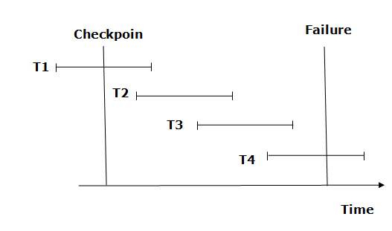
- The recovery system reads log files from the end to start. It reads log files from T4 to T1.
- Recovery system maintains two lists, a redo-list, and an undo-list.
- The transaction is put into redo state if the recovery system sees a log with <Tn, Start> and <Tn, Commit> or just <Tn, Commit>. In the redo-list and their previous list, all the transactions are removed and then redone before saving their logs.
- For example: In the log file, transaction T2 and T3 will have <Tn, Start> and <Tn, Commit>. The T1 transaction will have only <Tn, commit> in the log file. That's why the transaction is committed after the checkpoint is crossed. Hence it puts T1, T2 and T3 transaction into redo list.
- The transaction is put into undo state if the recovery system sees a log with <Tn, Start> but no commit or abort log found. In the undo-list, all the transactions are undone, and their logs are removed.
- For example: Transaction T4 will have <Tn, Start>. So T4 will be put into undo list since this transaction is not yet complete and failed amid.

SHADOW PAGING
Shadow Paging is recovery technique that is used to recover database. In this recovery technique, database is considered as made up of fixed size of logical units of storage which are referred as pages. pages are mapped into physical blocks of storage, with help of the page table which allow one entry for each logical page of database. This method uses two page tables named current page table and shadow page table.

The entries which are present in current page table are used to point to most recent database pages on disk. Another table i.e., Shadow page table is used when the transaction starts which is copying current page table. After this, shadow page table gets saved on disk and current page table is going to be used for transaction. Entries present in current page table may be changed during execution but in shadow page table it never get changed. After transaction, both tables become identical.
This technique is also known as Cut-of-Place updating.
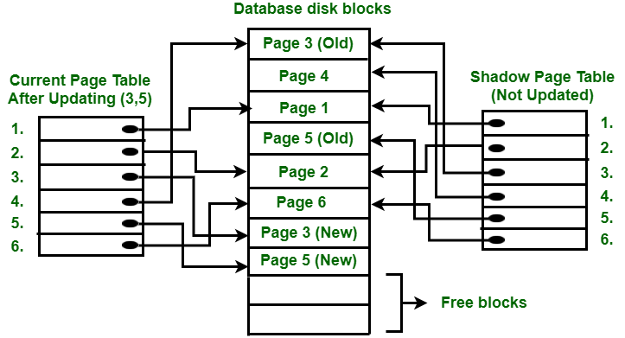
To understand concept, consider above figure. In this 2 write operations are performed on page 3 and 5. Before start of write operation on page 3, current page table points to old page 3.
When write operation starts following steps are performed:
- Firstly, search start for available free block in disk blocks.
- After finding free block, it copies page 3 to free block which is represented by Page 3 (New).
- Now current page table points to Page 3 (New) on disk but shadow page table points to old page 3 because it is not modified.
- The changes are now propagated to Page 3 (New) which is pointed by current page table.

COMMIT Operation:
To commit transaction following steps should be done:
- All the modifications which are done by transaction which are present in buffers are transferred to physical database.
- Output current page table to disk.
- Disk address of current page table output to fixed location which is in stable storage containing address of shadow page table. This operation overwrites address of old shadow page table. With this current page table becomes same as shadow page table and transaction is committed.
Failure :
If system crashes during execution of transaction but before commit operation, With this, it is sufficient only to free modified database pages and discard current page table. Before execution of transaction, state of database gets recovered by reinstalling shadow page table.
If the crash of system occurs after last write operation then it does not affect propagation of changes that are made by transaction. These changes are preserved and there is no need to perform redo operation.
Advantages:
- This method requires fewer disk accesses to perform operation.
- In this method, recovery from crash is inexpensive and quite fast.
- There is no need of operations like- Undo and Redo.
Disadvantages:
- Due to location change on disk due to update database it is quite difficult to keep related pages in database closes on disk.
- During commit operation, changed blocks are going to be pointed by shadow page table which have to be returned to collection of free blocks otherwise they become accessible.
- The commit of single transaction requires multiple blocks which decreases execution speed.
- To allow this technique to multiple transactions concurrently it is difficult.

